VRET Game Design Document (GDD)

# Game Name: Virtual Reality for Exposure Therapy in the Treatment of Acrophobia

## Genre: Serious Games

Virtual reality exposure therapy can offer many benefits in the health care contexts. Individuals who suffer from specific phobias, post-traumatic stress disorder, anxiety disorders, and more can utilize VR therapy to help minimize symptoms and feel more comfortable in certain situations. Severe fear of heights, or **acrophobia**, is a phobia subtype that involves a psychological barrier to confrontations with heights often leading to the avoidance of height-related objects and situations (i.e., stairs, terraces, etc.). This VR experience is designed to augment clinical treatments of acrophobia with gradual exposure to height-related scenes in the virtual realm.

Cognitive-behavioral therapy is the first line of treatment for fears and phobias. This VR experience is aligned with a treatment approach that is based upon the principle that when people are frequently exposed to stimuli that provoke anxiety such as thoughts, objects, or situations, with no subsequent negative consequences, individuals show a reduction of anxiety symptoms over time.

# Game Elements:

The VR game consists of **realistic height scenarios** and immersive VR environments that simulate different situations and environments such as skyscrapers, mountains, and local landmarks such as Kingdom tower and realistic audio to enhance user sessions. The game begins in an elevator at ground level and follows a rule of **gradual exposure levels** from low (ground floor) to high (top floor) to gradually desensitize players and disconnect them from their acrophobia. Users will be presented with a panel of several buttons in the elevator that leads to different levels which provides an **interactive environment** with physically grounded objectsfor users this aspect increases immersion and engagement. While using **therapy mode**, clinicians are able to record and assess the patients through metrics gathered from **Biofeedback integration** through Emotibit sensor integration and pupillometry which captures high quality emotional, physiological, pupil dilation,and movement data that is valuable to clinicians and solo players by enhancing their experience. The game has two modes that users can experience: **Therapy mode** where the session is guided by a clinician and **Solo session mode** where users interact with the system and participate in the game on their own with extra safety measures that assures a safe experience.

## Player:

The VR experience is designed for patients with acrophobia. Users can be the patients and/or the therapists (clinicians). As exposure to VR scenarios may provoke anticipatory fear, the therapist would need to explain to the patient that this is a normal response, and that exposure to a virtual environment is not in fact dangerous. To motivate the patients to engage in the VR-environment so that their irrational expectations could be falsified it would need to be emphasized prior to using the VR applications that VRET is in fact harmless. The game is targeted to solo users and users with acrophobia in (Therapy Mode). The game provides an immersive experience for two categories of users. Solo users are able to experience challenging activities such as standing on a plank on top of a skyscraper but in a safe environment that eliminates chances of injury whereas in Therapy mode users get to experience the immersive environments to gradually disconnect from their acrophobia under the supervision of a clinician that will record different metrics through sensors and customize a treatment plan suitable for each patient. The game is mainly targeted to users with acrophobia but could be enjoyable for other users that are not diagnosed with acrophobia. Users of all ages could use the game and children under the age of 13 can use the game under the supervision of an adult.

***TECHNICAL SPECS***

## Technical Form:

The game is in a 3D VR environment using the Quest 2 platform using the URP (Universal Rendering Pipeline) supported by the Quest 2. The game will also have realistic audio to help enhance immersion and user sessions. The Point of view of the game will be in first person for the player/patient and spectator mode for the clinician.

## View:

The player will begin the game in the ground floor of an elevator setting with a panel of buttons on the right for every level. Players will have the control of pressing the desired level on their own or under the supervision of the clinician. The second view is after the elevator door closes the elevator will start rising to the desired level/floor. The door will open upon arrival and the player will have a top view either on top of a mountain or a skyscraper where cars can be seen moving under the plank and birds and helicopters flying around and clouds around as well. Realistic audio of the environment around will enhance the experience and immersion. Several generated images shown are the potential settings of the game.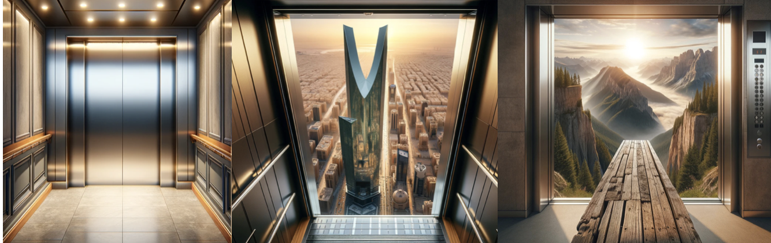

## Platform:

The game is developed on the Oculus Quest and OpenXR rig which has high compatibility with most consumer standalone VR headsets.

## Language:

The game is developed on the Unity engine using C# programming languages.

## Device:

The device used is the Quest 2 headset and controller. The Quest 2 can operate as a standalone headset with its onboard hardware or be connected to a PC via Oculus Link (a USB-C cable) to play PC VR games, offering flexibility in how it can be used.

The specifications are:

**The Oculus 2 headset:**

* **Display**: The Quest 2 features a single fast-switch LCD panel with a resolution of 1832 x 1920 pixels per eye, which is a significant upgrade from its predecessor. This high-resolution display offers clearer and more detailed images, enhancing the overall VR experience.
* **Processor:** It is powered by the Qualcomm Snapdragon XR2 Platform, which is specifically designed for VR and augmented reality (AR) experiences. This represents a considerable performance boost over the original Quest, supporting more complex and graphically intense VR content.
* **Refresh Rate:** The Quest 2 supports a refresh rate of up to 90 Hz (and experimented with 120 Hz in experimental features), providing smoother motion for a more comfortable and immersive VR experience.
* **Audio:** Integrated speakers deliver positional audio directly from the headset, eliminating the need for external headphones, though it also includes a 3.5mm headphone jack for users who prefer to use their own headphones.

**The Oculus 2 Controller:**

* **Oculus Insight Tracking:** The controllers use Oculus Insight, the same inside-out tracking technology that tracks the headset's position. This means the controllers are tracked by the cameras on the Quest 2 headset, eliminating the need for external sensors.
* **Precise Motion Tracking:** The controllers translate your hand and finger movements into the virtual environment with high accuracy, providing a seamless and responsive VR experience.
* **Analog Sticks and Buttons:** Each controller features an analog thumbstick, two face buttons, a system/menu button, and a trigger and grip button. This setup allows for a wide range of inputs, from simple navigation to complex gameplay mechanics.
* **Haptic Feedback:** The controllers include haptic feedback, which provides tactile sensations to simulate touch or interactions with objects in the virtual world, enhancing the realism of the VR experience.

# GAME PLAY

## Game Play Outline

* **Opening the game application:** Before starting the game users should calibrate the VR headset by setting the boundaries.When users launch the game they have customization options such as the gameplay mode they’d like to play either Therapy Mode or Solo Session Mode after that they have the option to choose the environment (natural environment, or city skyscrapers) after the users customize their experience they go into an elevator and get greeted by a plank setup.
* **Game options:**Users can customize their experience based on therapy needs, choosing from various environments and heights levels, each designed to progressively expose themselves to new heights in a controlled, safe manner. Users also have the option to choose their preferred gameplay mode and their desired environment before the start of the game.
* **Narrative and User Journey**:The game doesn't follow a traditional storyline but focuses on the personal journey of overcoming acrophobia. Users embark on a series of VR experiences, each tailored to gradually desensitize their acrophobia.. Users with acrophobia will go through an immersive VR experience that is both safe and helpful where patients will begin their treatment through the guidance of their clinician to gradually expose them to different heights while making sure they feel safe. It all starts in an elevator at the ground floor where patients will gradually progress to different levels of exposure by choosing one of the level buttons in the elevator starting from level 0-5 zero being the ground floor and five being the top level of a mountain or a skyscraper based on the patient’s preferences. Audio features of realistic sounds such as birds flying or helicopters flying will enhance the experience for the patient. Patients may have signs of discomfort as they progress through levels or stay for a period of time while standing on a plank; however clinicians will be able to comfort them and guide them in a safe manner through analyzing the data from the Biofeedback sensors to assess when to progress the patient to the next level. Patients do not progress to the next level until they feel comfortable at the current level and the patient is given a reward in terms of points linked to the Emotibit as they progress. Finally when the patient reaches the final level with comfort and normal heart rate the treatment is complete.
* **Modes:**

**-**. **Therapy Mode:** where the session is guided by clinicians and patients gradually increase their exposure until they desensitize from their acrophobia. While using therapy mode, clinicians are able to record and assess the patients through metrics gathered from Biofeedback integration through Emotibit sensor integration and pupillometry which captures high quality emotional, physiological, pupil dilation,and movement data that is valuable to clinicians.

- **Solo Session Mode:** where users interact with the system and participate in the game on their own with extra safety measures that assures a safe experience.Solo users are able to experience challenging activities such as standing on a plank on top of a skyscraper but in a safe environment that eliminates chances of injury.

* **Game elements:**

-The VR game consists of realistic height scenarios and immersive VR environments that simulate different situations and environments such as skyscrapers, mountains, and local landmarks such as Kingdom tower and realistic audio to enhance user sessions.

-The game begins in an elevator at ground level and follows a rule of gradual exposure levels from low (ground floor) to high (top floor) to gradually desensitize players and disconnect them from their acrophobia.

-Users will be presented with a panel of several buttons in the elevator that leads to different levels which provides an interactive environment with physically grounded objects for users this aspect increases immersion and engagement.

-While using therapy mode, clinicians are able to record and assess the patients through metrics gathered from Biofeedback integration through Emotibit sensor integration and pupillometry which captures high quality emotional, physiological, pupil dilation,and movement data that is valuable to clinicians and solo players by enhancing their experience.

-The game has two modes that users can experience: Therapy mode where the session is guided by a clinician and Solo session mode where users interact with the system and participate in the game on their own with extra safety measures that assures a safe experience.

* **Game levels and Gradual Exposure:** The game levels are linked to different levels on the elevator levels (0-5) zero being the ground floor and five being the top level of a mountain or a skyscraper based on the patient’s preferences.Patients may have signs of discomfort as they progress through levels or stay for a period of time while standing on a plank; however clinicians will be able to comfort them and guide them in a safe manner through analyzing the data from the Biofeedback sensors to assess when to progress the patient to the next level. Patients do not progress to the next level until they feel comfortable at the current level and the patient is given a reward in terms of points linked to the Emotibit as they progress.
* **Player’s controls**:Simple, intuitive controls are designed to ensure ease of navigation within the VR space. The game requires calibration when used in a new room to define boundaries and set up the plank. The game has Room-Scale Motion which allows users to move freely around a defined play area with real life movements. Users also use the controller to interact with the environment by pressing buttons on the elevator and interacting with the environment. Users also wear Emotibit sensors and integrate pupillometry which captures high quality emotional, physiological, pupil dilation,and movement data that is valuable to clinicians and solo players by enhancing their experience.
* **Winning:** Progress in overcoming acrophobia is measured by the user's ability to face increasingly challenging height scenarios without severe anxiety responses. The game has a scoring system linked to the Emotibit readings to reward milestones and blur out the lines of winning and losing.
* **Losing**:The game doesn't have a traditional losing condition but encourages users to progress at their own pace, offering support and encouragement to face their fears even after failure.
* **Why is all this relevant?**This VR experience is a tool for therapeutic intervention, providing a safe, controlled environment for users to confront and overcome their fear of heights, supplementing traditional therapy methods. Collaboration with clinicians during this process ensures the experience aligns with tried and tested methodology and evidence based practices for treating phobias. As some clinicians are bound to be skeptical against unproven and untested software. Developing a VR game for acrophobia treatment can be a turning point for treating different phobias in future in the medical field.

## Key Features

* **3D Immersive Environments:** High-quality graphics create immersive scenarios that closely mimic real-life heights and different environments including local landmarks to enhance the experience and immersion of locals.
* **Progressive Exposure Levels:** Designed to gradually expose users to increasing levels after a completion of a level based on biofeedback readings.
* **Customizable Therapy Sessions through several modes:** The game provides customizable options when it comes to environment setting and gameplay options. Therapy mode is under the guidance of a clinician targeted towards acrophobia patients and Solo session mode allows users to experience the game on their own with enhanced safety measures. This mode is targeted to patients and non-patients.
* **Realistic Audio**: realistic audio feature enhances the experience and immersion by making the setting more realistic for users. The audio feature includes a variety of sounds including birds, helicopters,cars, and people’s voices (noise).
* **Realistic height scenarios**: Immersive VR environments to simulate different situations,such as skyscrapers,bridges and mountains. The height gradually increases through an elevator progression of height that is under the control of a clinician in therapy mode and the user in SSM through a button panel in the elevator.
* **Biofeedback integration (Emotibit)**: the integration of the Emotibit which captures high quality emotional, physiological metrics and data that is valuable to clinicians to aid in deciding the progression of levels and the time of treatment.
* **pupillometry integration:** The integration of pupillometry in the VR headset can give valuable information on how the user is feeling through measuring the pupil dilation during the VR experience.
* **Oculus Quest and OpenXR rig development:** The development using Oculus Quest provides several libraries that can aid in the development process as well as using the OpenXR rig which has high compatibility with most consumer standalone VR headsets.
* **Room-Scale Motion:** Room scale motion allows users to move freely in a room with pre-determined boundaries and mirrors real life motions which enhances immersion and the VR experience.

# DESIGN DOCUMENT

## Design Guidelines

The design is guided by the principle of "do no harm," ensuring that all game elements are created with the utmost consideration for the user's psychological well-being. Realism, immersion, and gradual exposure are key aspects of the design, aimed at effectively aiding the treatment of acrophobia without causing undue distress.

## Game Sequence Diagrams:

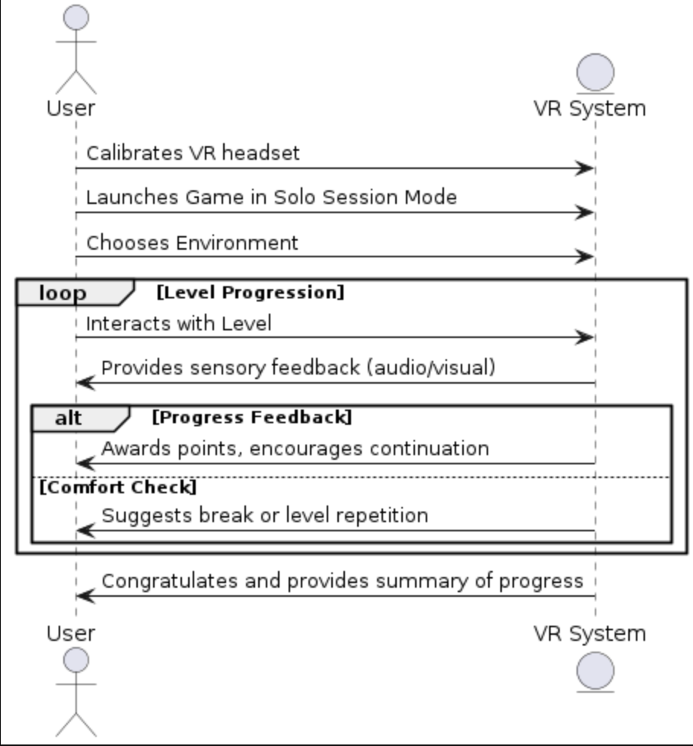

### 

### *Therapy mode sequence diagram *Solo Session mode sequence diagram

## Activity Diagram:

### 

### 

### 

### 

### 

### 

### Synopsis

Virtual reality (VR) integrates real-time computer graphics, body tracking devices, visual displays, and other sensory inputs to immerse individuals in a computer-generated virtual environment. In VRET, patients are exposed to virtual anxiety provoking environments instead of real anxious situations that are related to heights and elevations.

VRET is based on the assumption that people feel ‘present’ in the virtual environment. Presence is defined as ‘a psychological state or subjective perception in which, even though part or all of an individual’s current experience is generated by and/or filtered through human-made technology, part or all of the individual’s perception fails to accurately acknowledge the role of the technology in the experience’.

***Player Definitions***

Users of this VR experience can be of all genders, and ages however users under the age of 13 should use it under an adult’s supervision based on recommendations from meta. The game is targeted to people who would love to experience the challenge of standing at increasing heights and patients diagnosed with acrophobia use the game as a part of a treatment plan of acrophobia under the guidance and supervision of a clinician. Users can also interact with the environment by having control of the elevator through the buttons panel and freely move through the environment with sounds and audio which mimics a realistic setting.

### Player Rewards (power-ups and pick-ups)

Player rewards in the game are mainly incorporated to motivate users to progress and not give up. Rewards in the game are based on data from the Emotibit readings that are translated into points in the game. The main focus of the game is to ensure players / users are comfortable and motivated to follow through till they reach the final level. The game does not follow traditional losing or winning conditions. The goal is to offer support and encouragement to face their fears even after failure.

***User Interface (UI)***

The VR experience does not have a UI like traditional screens. In VR UI’s motion sickness, spatial awareness and user comfort is all taken into consideration to ensure better immersion and experience. This VR experience uses **environmental UI** by using objects in the game world and visual cues to guide users. **Minimize HUD(Heads-up display)** to increase immersion and motion sickness. Controls of the game are intuitive and linked to the game world interactions that allows users to navigate using their hands and body movements.